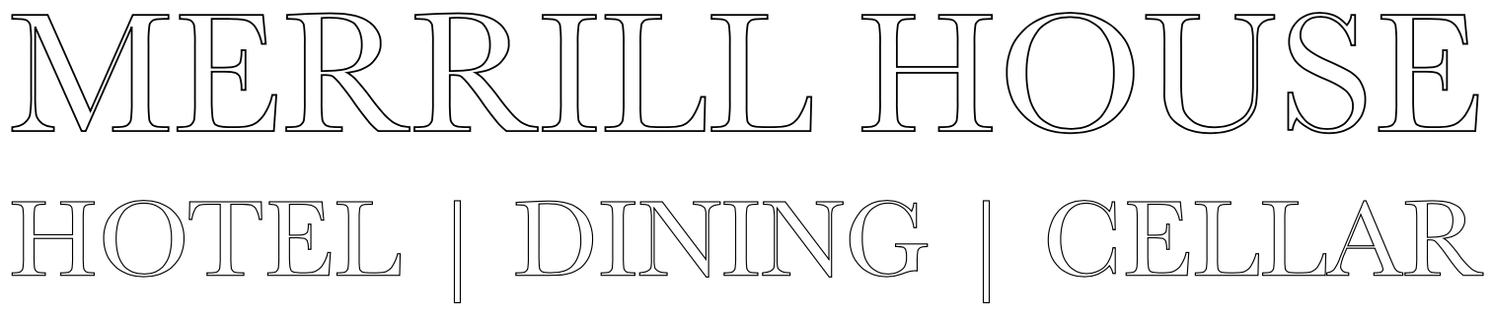
Employee Contact Information
Name: ___________________________________________________
Date of Birth: _____________________________________________
Email: ___________________________________________________
Phone Number: ____________________________________________
Street Address: _____________________________________________
City/Town: ______________________
Postal Code: ______________________
Province: ________________________
Emergency Contact Name: ____________________________________
Relation: __________________________________________________
Phone Number: _____________________________________________
For communication between departments and staff we use the application called Whatsapp. This is a data-based application used for messaging.
You will need to download this application on your phone- Once you have downloaded please let your manager know and we will add you to the Merrill House employee chat. This is not a group chat but rather a place for the owner and managers to relay important information pertaining to the hotel and restaurant operations.

